1. When UPDATING, CIPC STATUS & ACCOUNT STATUS changes were not saved.

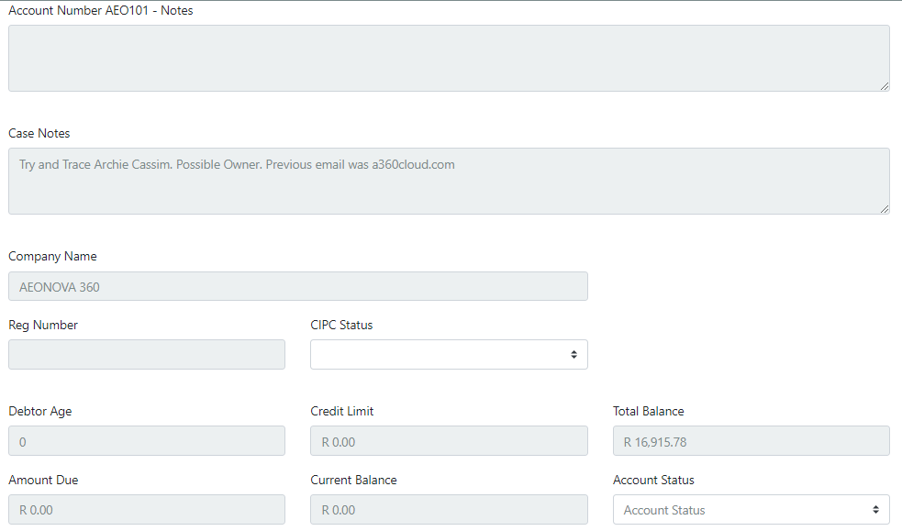

1. There’s a comma populated before every entry in OUTCOME NOTES

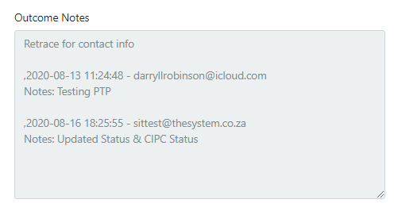

1. When PENDING a Case, all inputs must be saved as part of the OUTCOME. Things like Transaction Type, Number Called, Person Contacted, Email Used, Outcome, PTP Date and Amount, Resolution, Debit Order Date and Amount, Next Visit Date, Next Steps

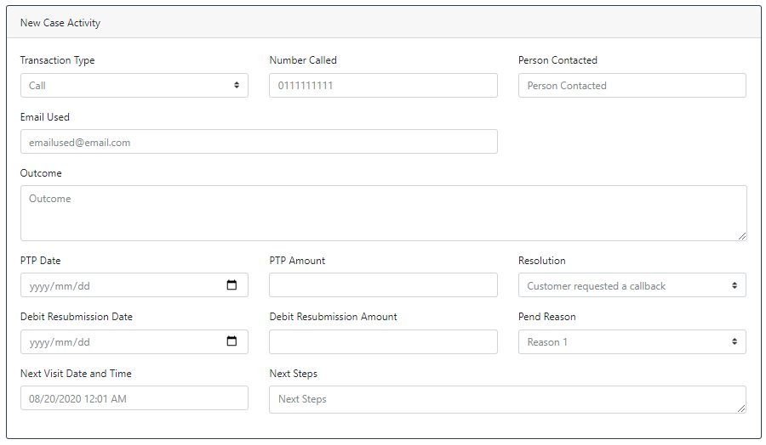

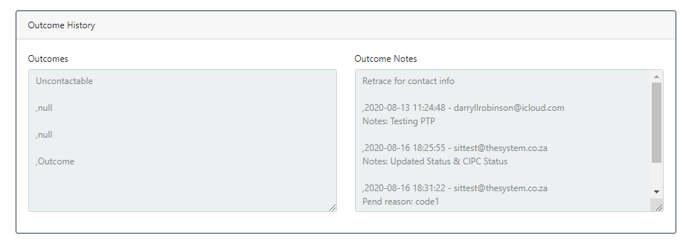

1. There is nowhere for me to view and update contact numbers and representatives.
2. The highlighted fields were not saved after PENDING…

